Support for Implicit Polymorphism

Within the caCORE SDK

What is Implicit Polymorphism?
Implicit Polymorphism is a Hibernate inheritance mapping strategy in which one or more of the super classes (parents) within the hierarchy are implicit.

What is an Implicit Parent Class?
Within the SDK, an implicit parent class is defined as a non-persistent super-class of a persistent leaf (child) class. From an SDK modeling perspective, it’s a super class without a corresponding table mapping.
The class diagram below illustrates two implicit parent classes, Tank and FishTank, highlighted in yellow:
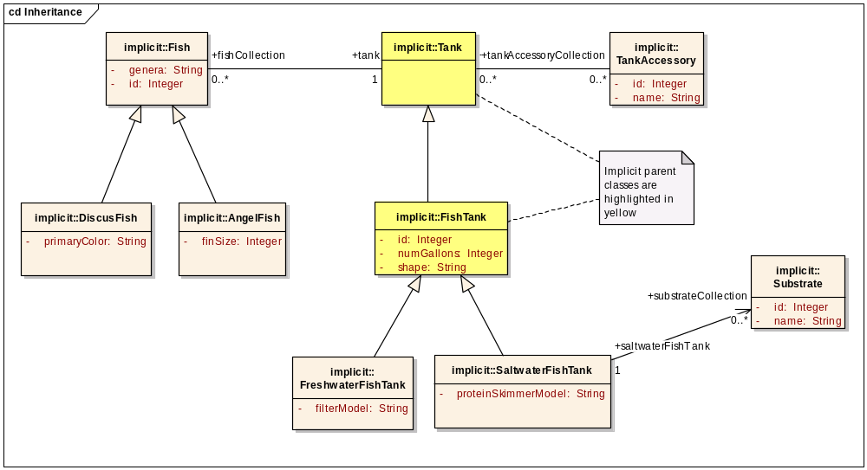
In this scenario, both Tank and FishTank are implicit parent classes with concrete, persistent subclasses, FreshwaterFishTank and SaltwaterFishTank.
A look at the corresponding table mapping diagram below shows that only the persistent subclasses, FreshwaterFishTank and SaltwaterFishTank, are mapped to a table; i.e., the implicit parents Tank and FishTank are not persistent, and thus have no mapping to a table via a DataSource stereotyped dependency link:
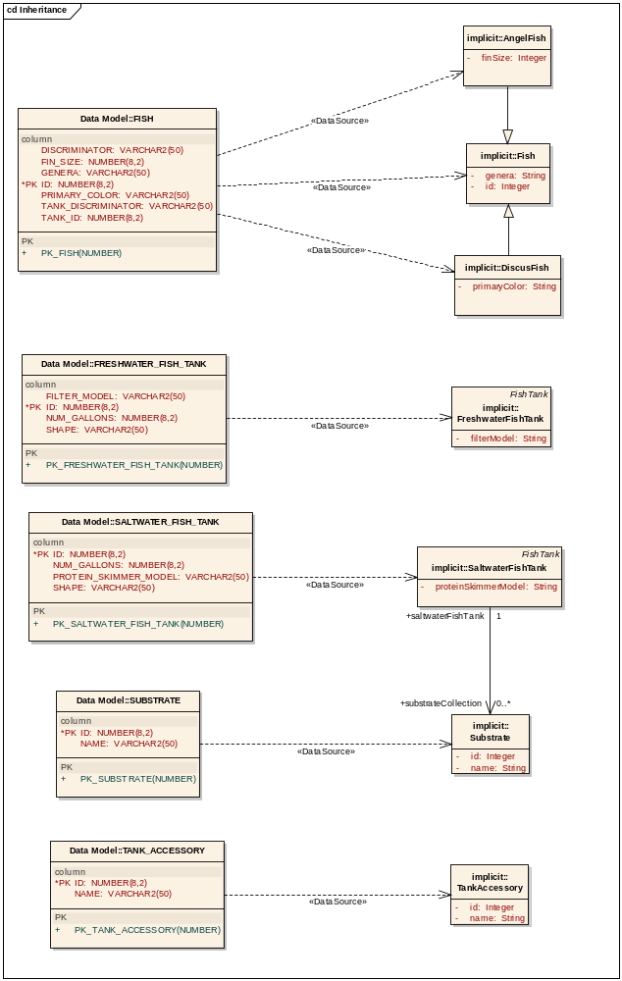

Supported Association Types:
Hibernate’s Implicit Polymorphism feature only supports the following two association types:
- Polymorphic many-to-one (<any>);
- Polymorphic many-to-many (<many-to-any>);
Thus, given the following modeling scenario:
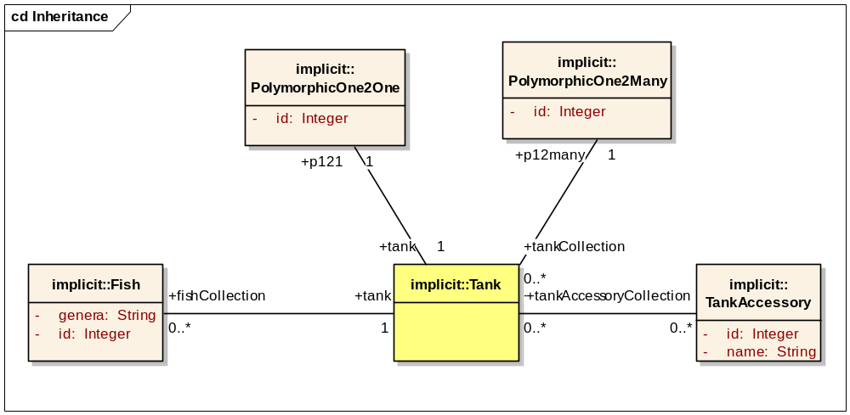
Only the associations between Fish and Tank and TankAccessory and Tank are valid. Here’s a list of each of the association types illustrated within the diagram:
- The association between class Fish and the implicit class Tank illustrates a polymorphic many-to-one (<any>) relationship;
- The association between class TankAccessory and the implicit class Tank illustrates a polymorphic many-to-many (<many-to-any>) relationship;
- The association between class PolymorphicOne2One and implicit class Tank illustrates a polymorphic one-to-one relationship. Note: This association is not currently supported by Hibernate, and will generate a validation error when the SDK generator is executed.
- The association between class PolymorphicOne2Many and implicit class Tank illustrates a polymorphic one-to-many relationship. Note: This association is also not currently supported by Hibernate, and will generate a validation error when the SDK generator is executed.

Modeling a Polymorphic Inheritance Hierarchy
The following scenario demonstrates a polymorphic inheritance hierarchy:
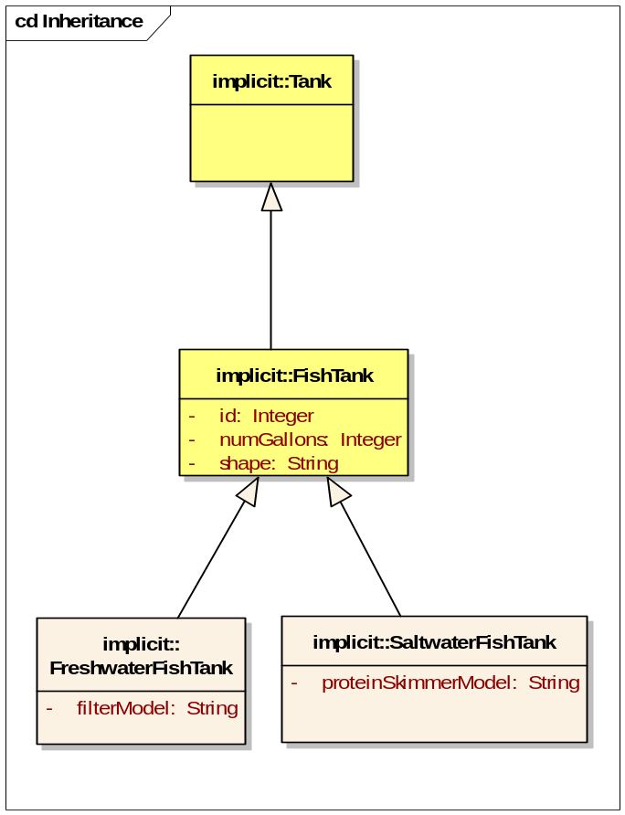
In this scenario, Tank and FishTank are implicit classes, and FreshwaterFishTank and SaltwaterFishTank are their concrete subclasses.
Since both Tank and FishTank are implicit classes, by definition, they do not have a corresponding table. In this case, a concrete class and a corresponding table are needed for each of the subclasses, FreshwaterFishTank and SaltwaterFishTank. Moreover, the columns which would typically be found in the table corresponding to the implicit classes (ID, NUM_GALLONS, and SHAPE) now get added to and repeated in each of the concrete subclass tables, as shown below:

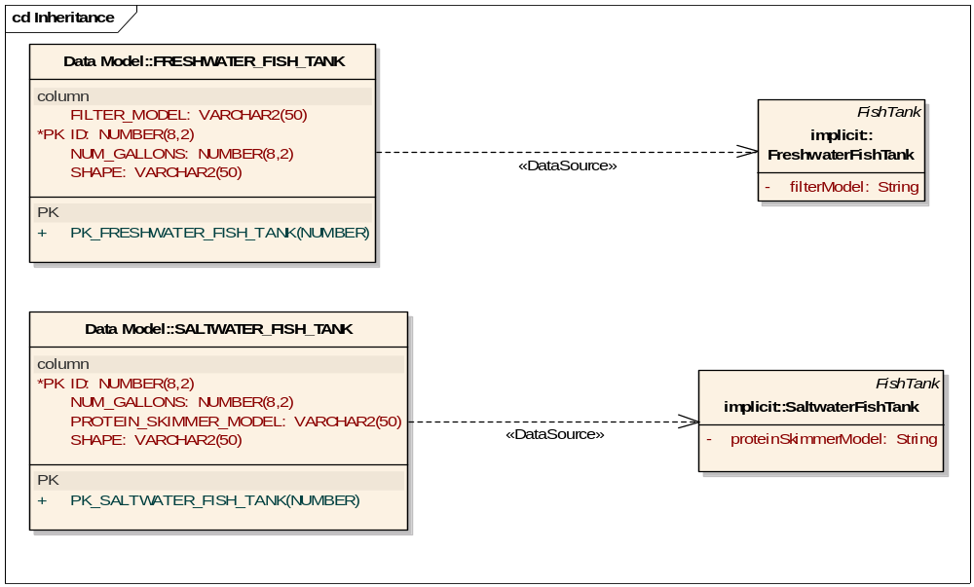
In this scenario, the following tag values must be added to each of the columns, as follows:
Table Name | Column Name | Tag Value Key | Tag Value <fully-qualified-class-name>.<class-attribute-name>
FRESHWATER_FISH_TANK | FILTER_MODEL | mapped-attributes | gov.nih.nci.domain.inheritance.implicit.FreshwaterFishTank.filterModel
FRESHWATER_FISH_TANK | ID | mapped-attributes | gov.nih.nci.domain.inheritance.implicit.FreshwaterFishTank.id
FRESHWATER_FISH_TANK | NUM_GALLONS | mapped-attributes | gov.nih.nci.domain.inheritance.implicit.FreshwaterFishTank.numGallons
FRESHWATER_FISH_TANK | SHAPE | mapped-attributes | gov.nih.nci.domain.inheritance.implicit.FreshwaterFishTank.shape
SALTWATER_FISH_TANK | ID | mapped-attributes | gov.nih.nci.domain.inheritance.implicit.SaltwaterFishTank.id
SALTWATER_FISH_TANK | NUM_GALLONS | mapped-attributes | gov.nih.nci.domain.inheritance.implicit.SaltwaterFishTank.numGallons
SALTWATER_FISH_TANK | PROTEIN_SKIMMER_MODEL | mapped-attributes | gov.nih.nci.domain.inheritance.implicit.SaltwaterFishTank.proteinSkimmerModel
SALTWATER_FISH_TANK | SHAPE | mapped-attributes | gov.nih.nci.domain.inheritance.implicit.SaltwaterFishTank.shape

Modeling a Polymorphic Many-to-One (<any>) Association
The association between Fish and Tank in the following diagram illustrates a polymorphic many-to-one (<any>) scenario:
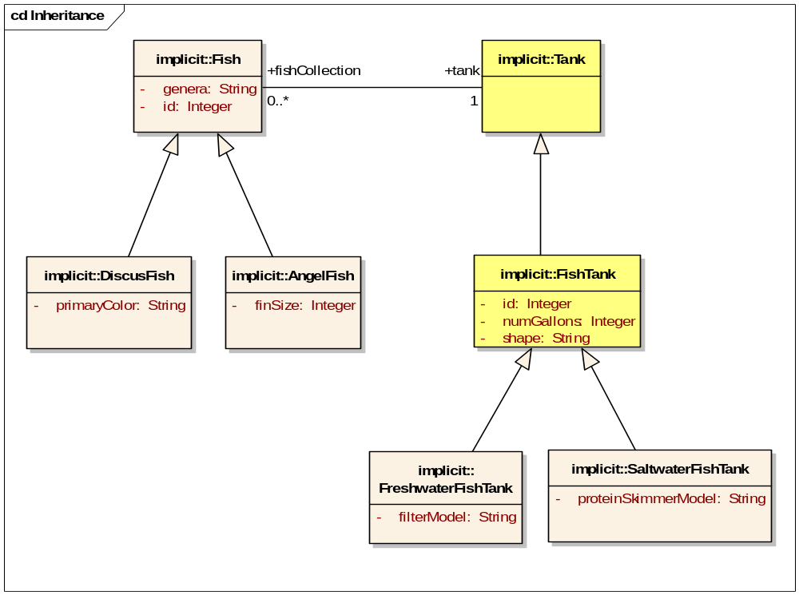
In this scenario, since Tank and FishTank are implicit classes, only Fish, FreshwaterFishTank, and SaltwaterFishTank will have a corresponding mapped table. The table mapping for the Fish class hierarchy is shown below:

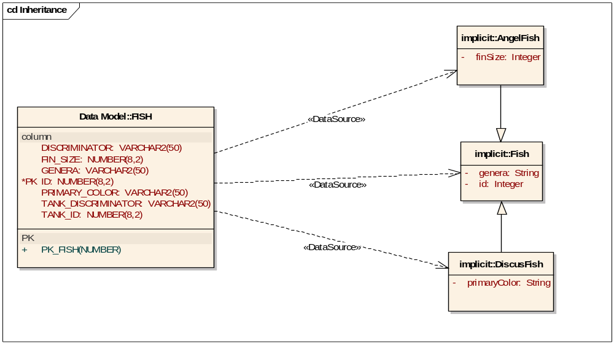
In this scenario, the following tag values must be added to each of the columns:
Table Name | Column Name | Tag Value Key | Tag Value
FISH | DISCRIMINATOR | discriminator | gov.nih.nci.cacoresdk.domain.inheritance.implicit.Fish
FISH | FIN_SIZE | mapped-attributes | gov.nih.nci.cacoresdk.domain.inheritance.implicit.AngelFish.finSize
FISH | GENERA | mapped-attributes | gov.nih.nci.cacoresdk.domain.inheritance.implicit.Fish.genera
FISH | ID | mapped-attributes | gov.nih.nci.cacoresdk.domain.inheritance.implicit.Fish.id
FISH | ID | inverse-of | gov.nih.nci.cacoresdk.domain.inheritance.implicit.Fish.tankCollection
FISH | PRIMARY_COLOR | mapped-attributes | gov.nih.nci.cacoresdk.domain.inheritance.implicit.DiscusFish.primaryColor
FISH | TANK_DISCRIMINATOR | discriminator | gov.nih.nci.cacoresdk.domain.inheritance.implicit.Fish.tank
FISH | TANK_ID | implements-association | gov.nih.nci.cacoresdk.domain.inheritance.implicit.Fish.tank

Since no correlation-table was specified as a tag value on the association link between Fish and Tank, TANK_ID is included as a Foreign Key to Tank, even though Tank does not have a mapped table. Also, since Tank is implicit and does not have a corresponding table, TANK_DISCRIMINATOR is added to the associated Fish table (FISH) in order to distinguish between FreshwaterFishTank and SaltwaterFishTank instances. Finally, note that unlike a typical discriminator column such as DISCRIMINATOR, the TANK_DISCRIMINATOR column has a discriminator tag value that includes the rolename. This is required in order to distinguish a particular association in the event that multiple associations between Fish and Tank would have been added.

Modeling a Polymorphic Many-to-Many (<Many-to-Any>) Association
The following diagram illustrates a polymorphic many-to-many (<many-to-any>) association between the Tank and TankAccessory classes:

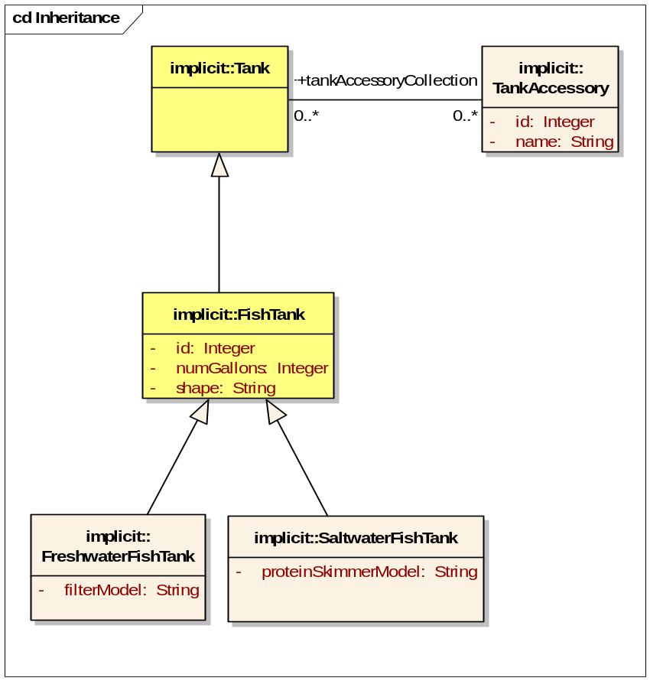
In this scenario, since Tank and FishTank are implicit classes, only TankAccessory, FreshwaterFishTank, and SaltwaterFishTank will have a corresponding mapped table. The table mapping for the TankAccessory class hierarchy is shown below:
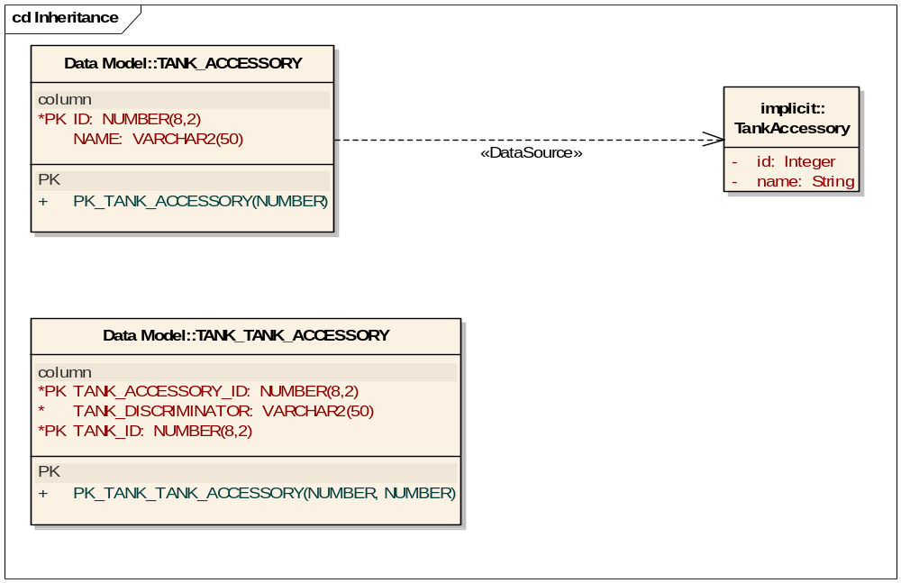
In this scenario, the following tag values must be added to each of the columns:
Table Name | Column Name | Tag Value Key | Tag Value
TANK_ACCESSORY | ID | mapped-attributes | gov.nih.nci.cacoresdk.domain.inheritance.implicit.TankAccessory.id
TANK_ACCESSORY | NAME | mapped-attributes | gov.nih.nci.cacoresdk.domain.inheritance.implicit.TankAccessory.name
TANK_TANK_ACCESSORY | TANK_ACCESSORY_ID | implements-association | gov.nih.nci.cacoresdk.domain.inheritance.implicit.Tank.tankAccessoryCollection
TANK_TANK_ACCESSORY | TANK_ACCESSORY_ID | inverse-of | gov.nih.nci.cacoresdk.domain.inheritance.implicit.TankAccessory.tankCollection
TANK_TANK_ACCESSORY | TANK_DISCRIMINATOR | discriminator | gov.nih.nci.cacoresdk.domain.inheritance.implicit.TankAccessory.tankCollection
TANK_TANK_ACCESSORY | TANK_ID | implements-association | gov.nih.nci.cacoresdk.domain.inheritance.implicit.TankAccessory.tankCollection
TANK_TANK_ACCESSORY | TANK_ID | inverse-of | gov.nih.nci.cacoresdk.domain.inheritance.implicit.Tank.tankAccessoryCollection

In this scenario, a correlation-table tag key with a value of TANK_TANK_ACCESSORY was also specified on the association link between Tank and TankAccessory. TANK_ID is included as a Foreign Key to Tank, even though Tank does not have a mapped table. Also, since Tank is implicit and does not have a corresponding table, TANK_DISCRIMINATOR is added to the correlation table (TANK_TANK_ACCESSORY) in order to distinguish between FreshwaterFishTank and SaltwaterFishTank instances. Finally, note that unlike a typical discriminator column, the TANK_DISCRIMINATOR column has a discriminator tag value that includes the rolename. This is required in order to distinguish a particular association in the event that multiple associations between Tank and TankAccessory would have been added.

Key Features of an Implicit Parent Class:
- Is non-persistent; i.e., does not have a corresponding table mapping or Hibernate mapping file, and thus is not listed in the Hibernate configuration file.
- May or may not be abstract
- Unlike other classes, does not require an id attribute, or any attribute, for that matter. The Tank super-class exemplifies this in our model scenario.
- Requires that, at minimum, any leaf node subclasses be persistent (concrete), and that their corresponding Hibernate mapping file have the polymorphism attribute set to “implicit” (vs. the typical setting of “explicit”). Both the FreshwaterFishTank and SaltwaterFishTank classes exemplify this in our model scenario.
- Requires that each persistent leaf sub-class be mapped to its own table, and that the table contain columns for all inherited implicit parent attributes/columns. If there is more than one persistent subclass, the inherited implicit parent attributes/columns are duplicated in each of the persistent subclass tables.
- Can be used in queries even though it is non-persistent. Hibernate will detect that an implicit parent class is being used in the query, and will fire off a query for each of the corresponding persistent subclasses, and then combine the results into a single result set.

Known Issues:
Implicit polymorphism queries fail if firstResult/maxResult attributes are set prior to executing a query. Hibernate Support has been contacted in an attempt to obtain a solution. Issue is located in ORMDAOImpl.java with the SDK. See GForge tracker [#13168] Polymorphic Implicit Inheritance queries fail if firstResult/maxResult is set prior to executing query for more details.

Known Limitations:
Again, Hibernate’s Implicit Polymorphism feature only supports the following association types:

- Polymorphic many-to-one (<any>);
- Polymorphic many-to-many (<many-to-any>);
For more information, refer to section 9.2 Limitations, of the Hibernate Reference manual.

See Also:
For more information on implicit polymorphism, refer to the following:
- The implicit polymorphism sample scenario contained within the … > inheritance > implicit package of the SDK Test models (SDKTestModel.EAP for the EA version, or sdk.uml for the Argo version) provided with the models directory of the SDK 4.1 distribution. The following diagram highlights the pertinent package containing the Logical Model classes (EA version shown):
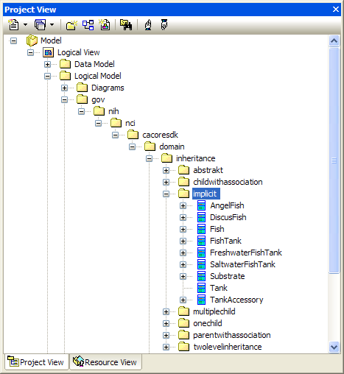
Also refer to the corresponding tables contained within the Data Model package, and the corresponding diagrams:
  - Inheritance class diagram located in the Logical Model > Diagrams package.
  - Table-to-class mapping Inheritance diagram located in the Mapping > Diagrams package.
- Hibernate Simplifies Inheritance Mappings: http://www.ibm.com/developerworks/java/library/j-hibernate/.
- Chapter 9, Inheritance Mapping, Sub-Section 9.1.6, Table per concrete class, using implicit polymorphism, of the Hibernate 3.x Reference manual: http://www.hibernate.org/5.html#A5.

